EX NO: 1b | CHARACTERISTICS STUDY OF SIDE BAND POWER AND FREQUENCIES IN AM USING MATLAB
DATE:
NAME : GNANAHASAN M
REG NO: (192412347)
COURSE NAME : ANALOG AND DIGITAL COMMUNICATION (ECA0802)

Objectives:
i) To generate an Amplitude Modulated (AM) signal in MATLAB using specified carrier and modulating signal parameters.
ii) To determine and verify the upper sideband (USB) and lower sideband (LSB) frequencies of the AM signal using frequency spectrum analysis in MATLAB.
iii) To calculate the carrier power, sideband power, and total transmitted power of the AM signal for a given modulation index using MATLAB.
iv) To analyze the effect of varying the modulation index on sideband power distribution and overall transmission efficiency through MATLAB simulation.
Objective 1:
To generate an Amplitude Modulated (AM) signal in MATLAB using specified carrier and modulating signal parameters
PROGRAM (MATLAB CODE)
clc;
clear;
close all;
Am=1;
fm=500;
Ac=5;
fc=5000;
fs=20*fc;
t=0:1/fs:4/fm;
m = Am*sin(2*pi*fm*t);
c = Ac*sin(2*pi*fc*t);
mu = Am/Ac;
am = Ac*(1+mu*sin(2*pi*fm*t)).*sin(2*pi*fc*t);
dem = abs(hilbert(am)); dem = dem-mean(dem);
N=length(am); f=linspace(-fs/2,fs/2,N);
AM_FFT=abs(fftshift(fft(am)))/N;
USB=fc+fm; LSB=fc-fm;
Pc=Ac^2/2; Psb=(mu^2*Pc)/4;
figure('Name','AM Modulation','NumberTitle','off');
subplot(3,2,1), plot(t,m), title('Message'), grid on
subplot(3,2,2), plot(t,c), title('Carrier'), grid on
subplot(3,2,3), plot(t,am), title('AM Signal'), grid on
subplot(3,2,4), plot(t,dem), title('Demodulated'), grid on
subplot(3,2,5), plot(f,AM_FFT), xlim([fc-3*fm fc+3*fm]), title('Sidebands'), grid on
subplot(3,2,6), bar([Pc Psb Psb]), set(gca,'XTickLabel',{'Carrier','USB','LSB'}),
title('Power'), grid on
fprintf('μ=%.2f | USB=%d Hz | LSB=%d Hz | Pc=%.2f W | Psb=%.3f W\n',mu,USB,LSB,Pc,Psb);

Procedure
- Open MATLAB and create a new script file.
- Initialize the MATLAB workspace by clearing all variables, command window contents, and open figure windows using:
clc; clear; close all;
- Define the message signal amplitude (), message frequency (), carrier amplitude (), carrier frequency (), and sampling frequency ().
- Generate the time vector required for signal simulation using the specified sampling frequency.
- Generate the message signal using a sinusoidal waveform with frequency .
- Generate the carrier signal using a sinusoidal waveform with frequency .
- Calculate the modulation index () using:
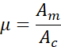
- Generate the Amplitude Modulated (AM) signal using the standard AM equation:
- Demodulate the AM signal using the Hilbert Transform to obtain the envelope of the modulated signal.
- Remove the DC component from the demodulated signal to recover the original message signal.
- Compute the Fast Fourier Transform (FFT) of the AM signal to analyze its frequency spectrum.
- Determine the Upper Sideband (USB) and Lower Sideband (LSB) frequencies using:
- Calculate the carrier power and sideband power using:
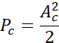
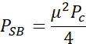
- Plot the message signal, carrier signal, AM signal, demodulated signal, frequency spectrum showing sidebands, and power distribution using MATLAB subplot commands.
- Display the values of modulation index, sideband frequencies, carrier power, and sideband power in the MATLAB Command Window using the fprintf() function.
- Observe and analyze the generated plots to verify the AM waveform characteristics, sideband frequencies, and power distribution.

OUTPUT (GRAPH)
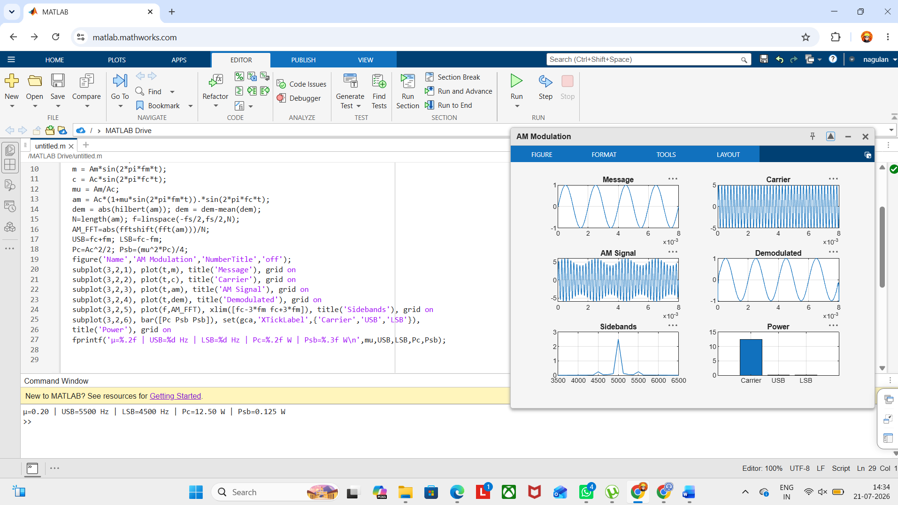

Result
The AM signal was successfully generated and analyzed in MATLAB.

